Task Description:

Establish a new directory, populate it with script files, initiate an empty repository on GitHub, convert the local directory into a Git repository, and link it to GitHub for pushing the code into the repository.Perform merge, rebase, stash commands in following github repo.

Repository created for task:
subbasri17/GIT-Scenario-Practice: Git practice for devops training
Instance creation done:
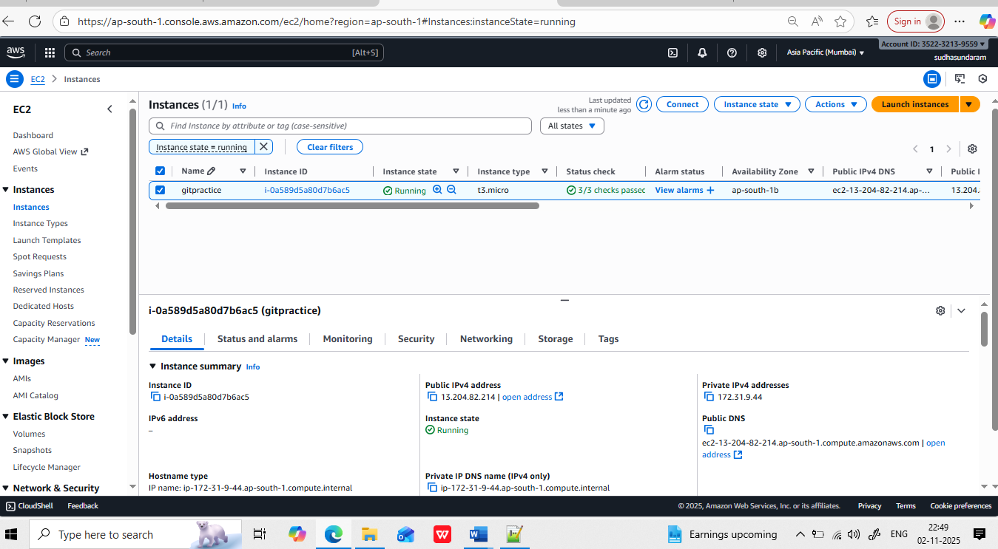

2.Connecting server through putty installing git, and making own directory and and do git init and the staging the file into staging and local repo
Then pushing the file from local repo to remote repo.

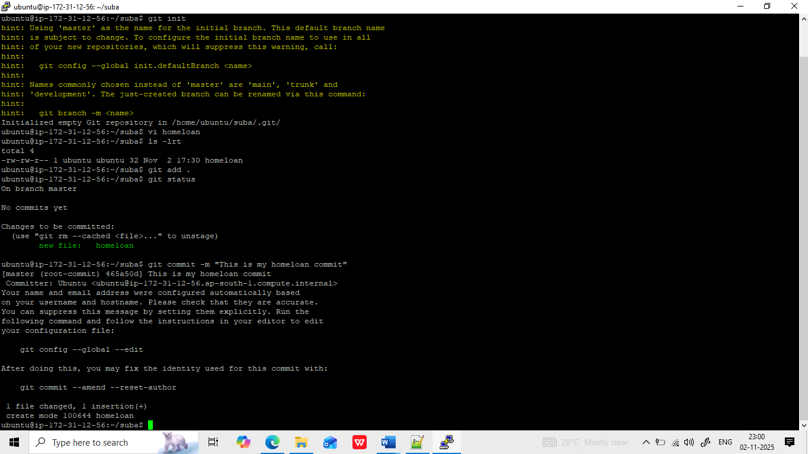

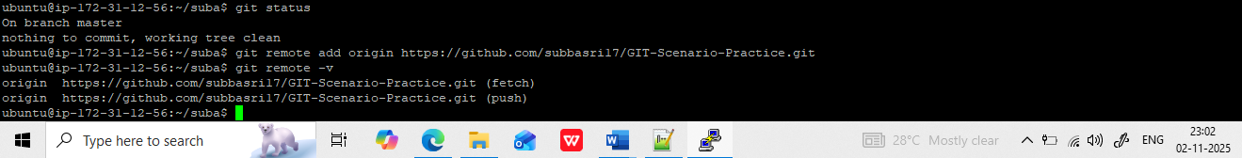

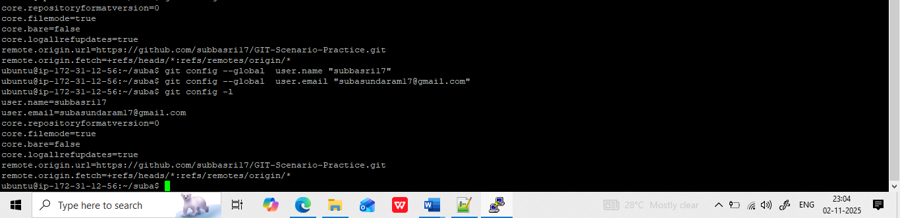

Push the code into git hub:
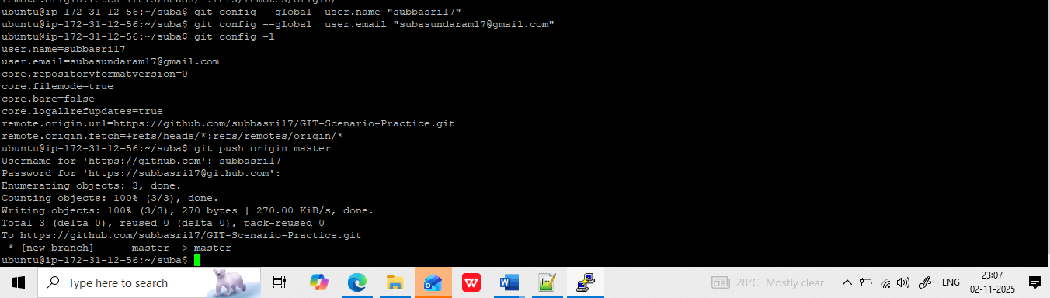
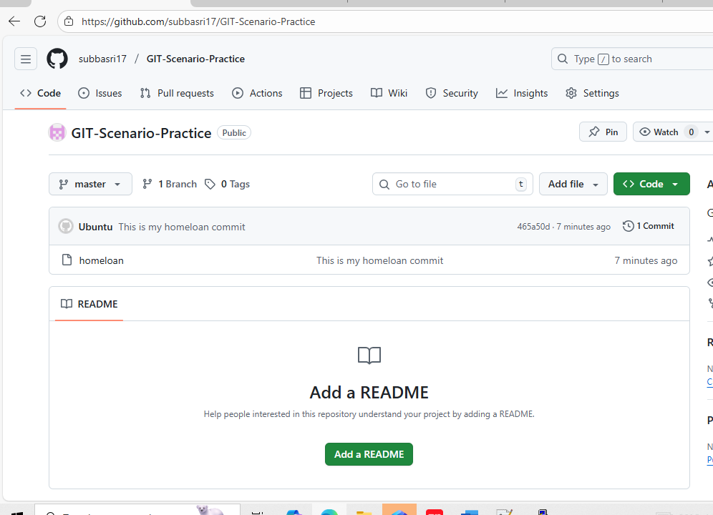

Merge:

Creating a new branch bike loan:
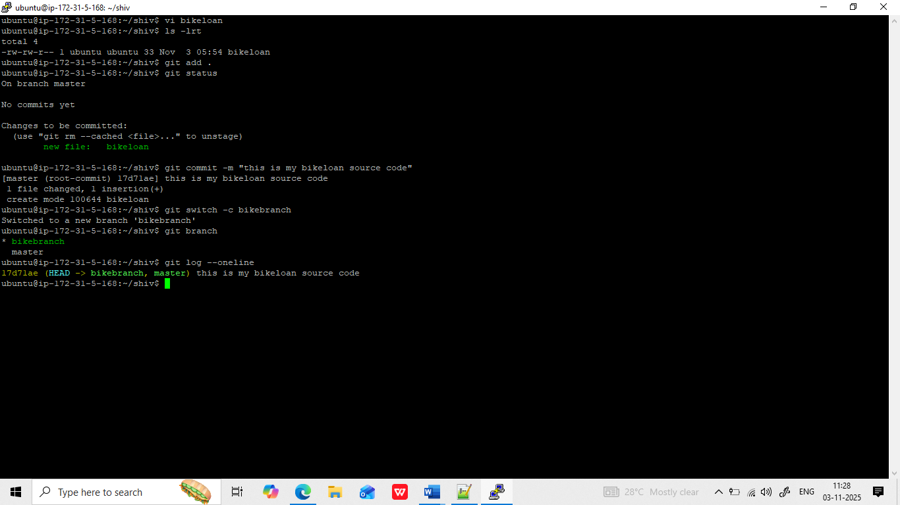
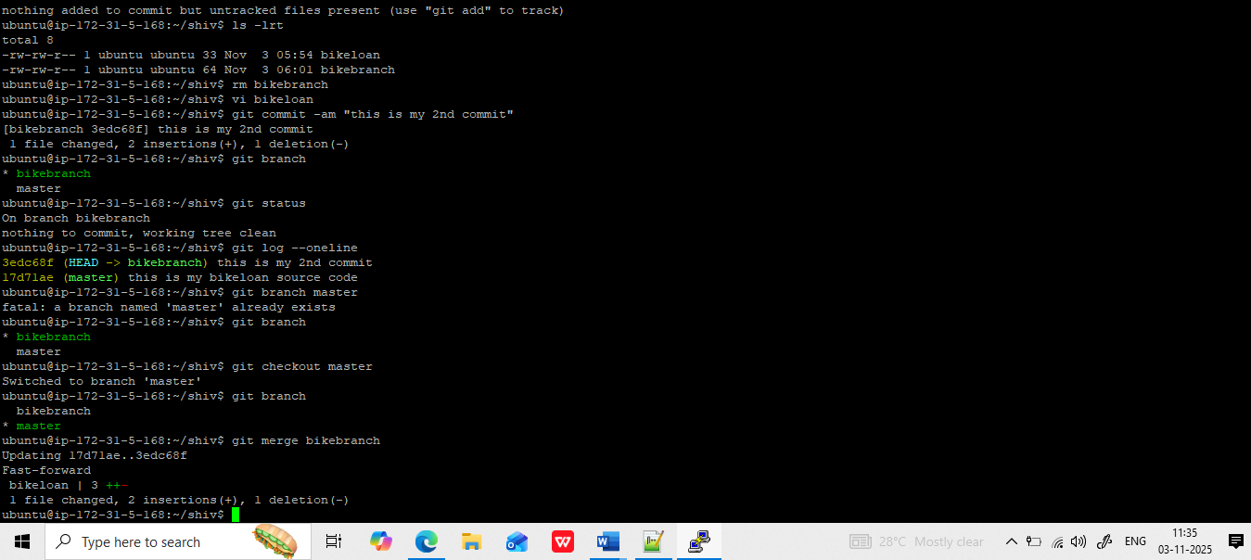
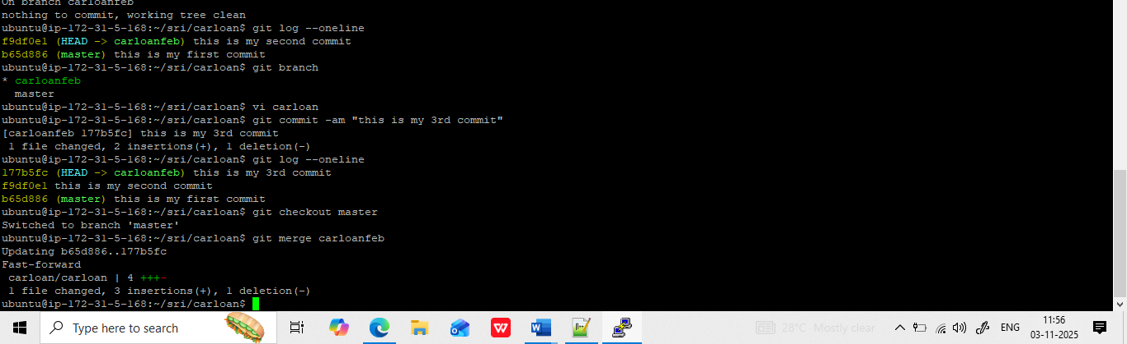

Rebase: taking all changes in the master branch and across it to all the branches
it will do all the changes in the feature branches.

